Centripetal Force

Any force or combination of forces can cause a centripetal or radial acceleration. Just a few examples are the tension in the rope on a tether ball, the force of Earth’s gravity on a satellite, the friction between roller skates and a rink floor, and a banked roadway’s force on a car.
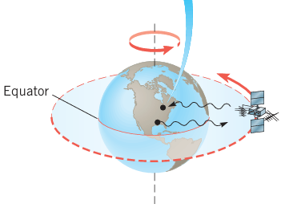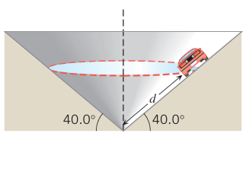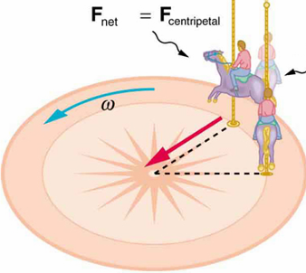

Any net force causing uniform circular motion is called a centripetal force. The direction of a centripetal force is toward the center of curvature, the same as the direction of centripetal acceleration.

According to Newton’s second law of motion, net force F is mass times acceleration: Fnet = ma.
For uniform circular motion, the acceleration is the centripetal acceleration ac, Thus, the magnitude of centripetal force Fc is: ${F_{c}=ma}_{c}$, Since the centripetal acceleration $a_{c}=\frac{v^{2}}{R} , or$ $a_{c}=ω^{2}R$, then:
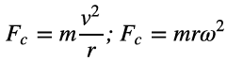
Note: The phrase “centripetal force” does not denote a new and separate force created by nature. The phrase merely labels the net force pointing toward the center of the circular path, and this net force is the vector sum of all the force components that point along the radial direction.

Example 1: The model airplane with a mass of 0.90 kg moves at a constant speed on a circle that is parallel to the ground. The path of the airplane and its guideline lie in the same horizontal plane, because the weight of the plane is balanced by the lift generated by its wings. Find the tension in the guideline (length 17 m) for speeds of 19 and 38 m/s.
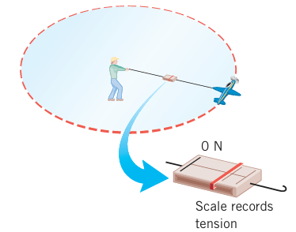

$a_{c}=\frac{v^{2}}{R} , or$ $a_{c}=ω^{2}R$, ${F_{c}=ma}_{c}$, ${F_{c}=m\frac{v^{2}}{R}, or }_{}F_{c}=m ω^{2}R$
Example 2: Centripetal Force and Safe Driving

When a car moves at a steady speed around an unbanked curve, the centripetal force keeping the car on the curve comes from the static friction between the road and the tires.
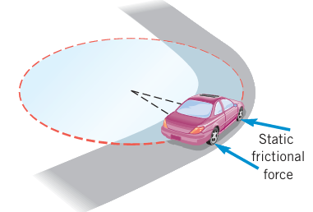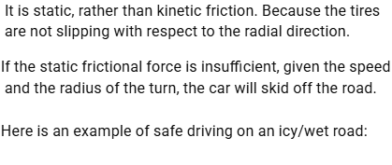

Question: At what maximum speed can a car safely negotiate a horizontal unbanked turn (radius 51 m) in dry weather (coefficient of static friction 0.95) and icy weather (coefficient of static friction 0.10)?

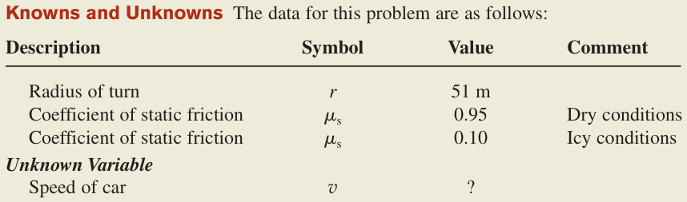

$a_{c}=\frac{v^{2}}{R} , or$ $a_{c}=ω^{2}R$, ${F_{c}=ma}_{c}$, ${F_{c}=m\frac{v^{2}}{R}, or }_{}F_{c}=m ω^{2}R$
Practice Problems: 1. What Coefficient of Friction Do Car Tires Need on a Flat Curve?
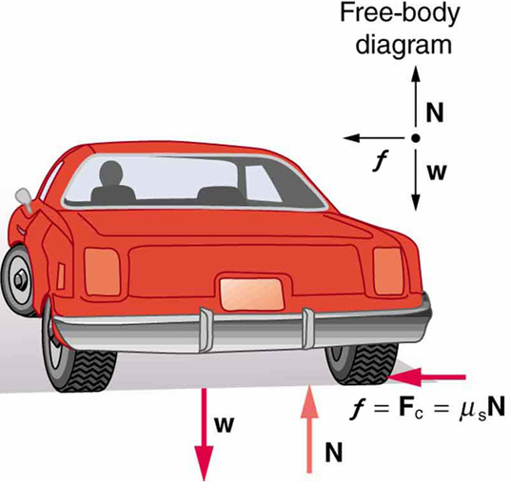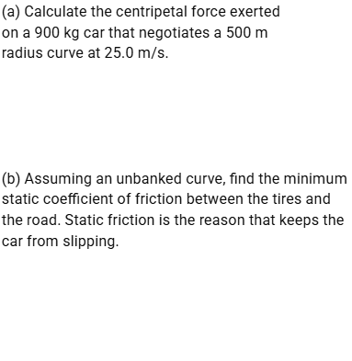

2. Car A uses tires for which the coefficient of static friction is 1.1 on a particular unbanked curve. The maximum speed at which the car can negotiate this curve is 25 m/s. Car B uses tires for which the coefficient of static friction is 0.85 on the same curve. What is the maximum speed at which car B can negotiate the curve?

3. A penny is placed at the outer edge of a disk (radius 0.150 m) that rotates about an axis perpendicular to the plane of the disk at its center. The period of the rotation is 1.80 s. Find the minimum coefficient of friction necessary to allow the penny to rotate along with the disk.

8. Three particles have the following masses (in multiples of m0) and move on three different circles with the following speeds (in multiples of v0) and radii (in multiples of r0):
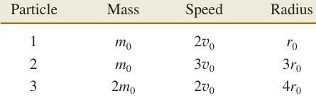
Rank the particles according to the magnitude of the centripetal force that acts on them, largest first. (a)1, 2, 3 (b)1, 3, 2 (c)2, 1, 3 (d)2,3,1 (e)3,2,1

16. A speed skater goes around a turn that has a radius of 31 m. The skater has a speed of 14 m/s and experiences a centripetal force of 460 N. What is the mass of the skater?

18. A car is safely negotiating an unbanked circular turn at a speed of 21 m/s. The road is dry, and the maximum static frictional force acts on the tires. Suddenly, a long wet patch in the road decreases the maximum static frictional force to one-third of its dry-road value. If the car is to continue safely around the curve, to what speed must the driver slow the car?

22. An 830-kg race car can drive around an unbanked turn at a maximum speed of 58 m/s without slipping. The turn has a radius of curvature of 160 m. Air flowing over the car’s wing exerts a downward-pointing force (called the downforce) of 11000 N on the car.
(a) What is the coefficient of static friction between the track and the car’s tires?
(b) What would be the maximum speed if no downforce acted on the car?

